Design Document 2024　Munako Artemis

Munakata High School Electric Physics Club

Region: Japan

League: Soccer Light Weight

Team member: Kyle Matsuda, Yuki Meno, Rentaro Ishihara, Ryota Kumadaki

Team HP: <https://munako-artemis.github.io/>

**Team Introduction:**Munako Artemis is a Japanese team participating in Soccer LWL. The team consists of four high school students and has been active since 2021.

**Members:**

・Kyle Matsuda : Robot 1 Hardware (Robot design, Circuit design)

・Yuki Meno : Robot 2 Hardware (Robot design, machining)

・Rentaro Ishihara: Robot 1 Software, Team management (Low layer programing)

・Ryota Kumadaki: Robot 2 Software (Main program)

**Abstract**

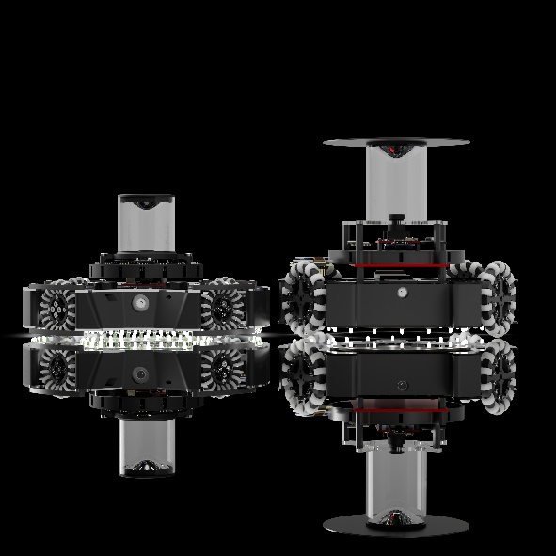 This year, we developed two types of robots. The robot in the left of fig.1 is designed to have a low center of gravity and high maintenance performance. The right one is designed to be a strong robot with stable operation. In the developments of these two robots, we made modifications to our robots to address various issues identified in the Japan Open 2024.

We were given an extremely short preparation period for the world championship, so we proceeded with multiple workflows, which not only allowed us to start working on tasks earlier but also created significant time flexibility.

Fig.1 (robots for the world championship)

**Team Management**

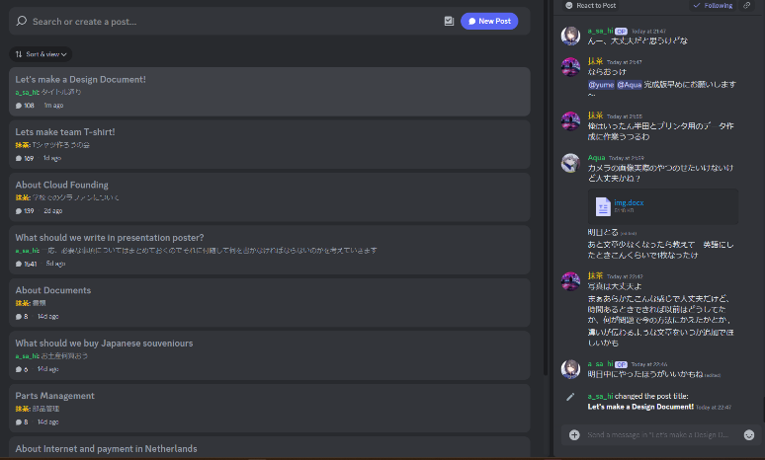Our team is primarily divided into hardware and software teams. As a result, it was often difficult to understand the status of each team during actual activities. Additionally, the time available for work was limited due to the short period until the competition. Therefore, we made significant improvements in two main areas regarding our team activities.

Fig.2 Task Management Tool (Google Spreadsheet) Fig.3 Communication Tool (Discord)

**<Task Visualization and Smooth Communication>**

To visualize tasks, we used Google Spreadsheet. With Google Spreadsheet, we list and manage each team member's tasks (Fig.2). Since it can be used online, tasks can be checked at any time. Any team member can add, delete, or edit tasks on the list, making it easy to reassign tasks to other team members if any issues arise. This allows the entire team to stay updated. This tool made task visualization clear and facilitated smooth team activities.

For smooth communication, we used Discord. Discord was primarily used for discussions related to team activities (Fig.3). By using the Discussion function, we could create channels for each topic, enabling smooth discussions on specific topics.

**<Workflow Improvement>**

We had a short preparation period leading up to the world championship, necessitating efficient work processes. To address this, we focused on "improving our workflow."

Fig.4 Single Workflow System (From Our Presentation Poster)

Previously, as shown in Fig.4, we followed a workflow system where tasks were completed one at a time. This method ensured more reliable results, but it takes longer to process tasks sequentially. As a result, it made it difficult to provide feedback from software development issues to the hardware team

F ig.5 Multiple Workflow System (From Our Presentation Poster)

Therefore, we adopted a multitasking flow, as depicted in Fig.5, where team members work on multiple tasks in parallel. By working on tasks simultaneously, we enabled feedback from software to hardware, allowed system changes during the design phase, and confirmed the operation of each component before the robot's completion. This approach facilitated smoother program adjustments for the robot post-completion. By implementing these improvements in team activities, we were able to develop the robot smoothly and facilitate efficient team collaboration within a short period.

**Robot Specifics**

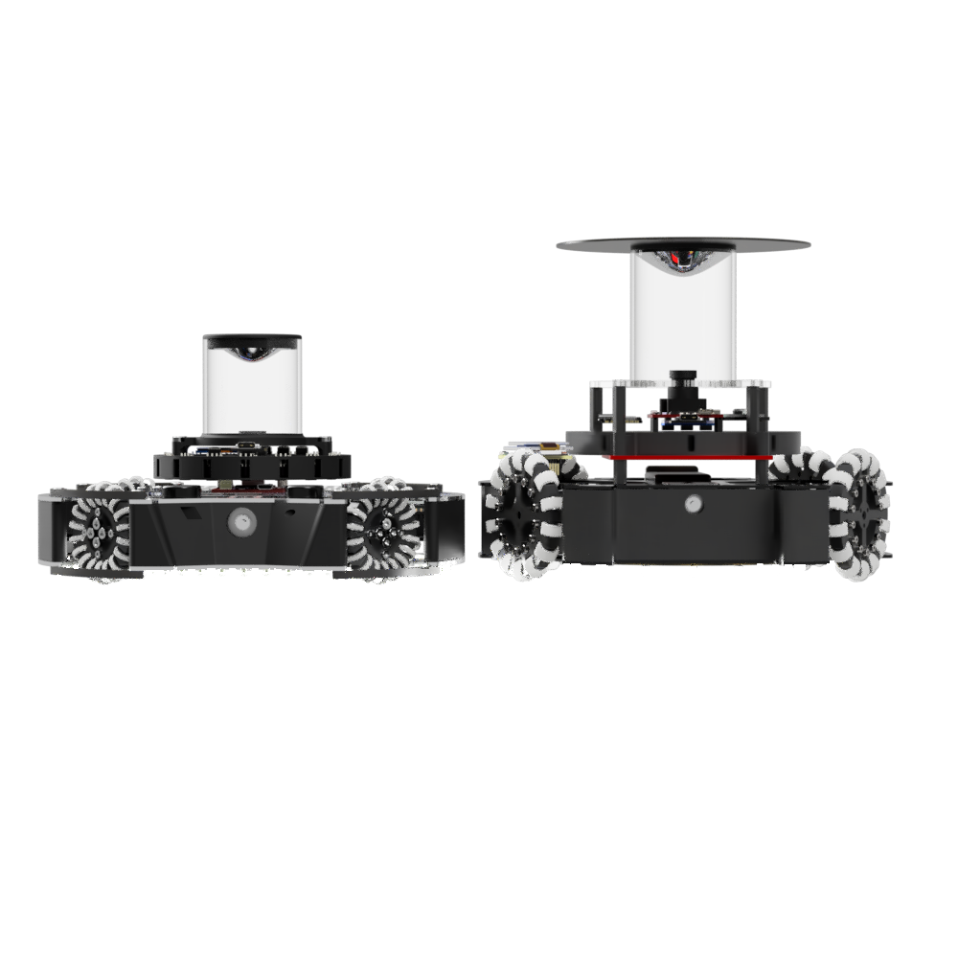**<Robots’ Overview>**

Fig.6 robots for the world championship (left: robot1 right: robot2)

Robot.1's concept is to be a "robot with a low center of gravity and high maintenance performance”. Also, it has been designed with a reduced number of components, ensuring ease of maintenance despite its low-profile design. Robot.2's concept is to be a "strong robot with stable operation". Additionally, it is designed to place various additional components for adapting to changes in rules.

**<Robot1 Mechanical>**

**・low center of gravity 時計と文字の加工写真

**

Fig.7 The position of the center of gravity of Robot 1.

This robot prioritizes a low center of gravity.

The pink dots shown in Fig.7 indicate the robot's center of gravity.

A low center of gravity allows the robot to execute turns and speed changes with minimal force, reducing power consumption and enabling more precise movements.

However, achieving a low center of gravity often means designing the robot to be compact and

densely packed with components internally, potentially compromising maintenance accessibility.

To address this problem, we made various improvements shown on the next page to this robot.

**・maintenance performance**

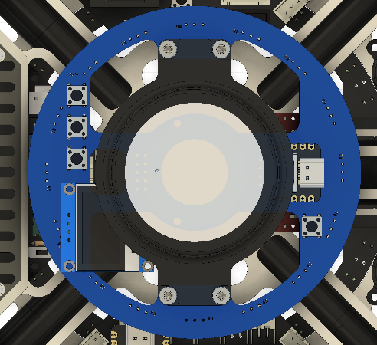

Fig.8 The shapes and location of some of the biggest boards in the robots. (Boards are colored in blue)

As mentioned earlier, low profile robots mean designing the robot to be densely packed with components internally, potentially compromising maintenance accessibility. Therefore, we paid special attention to the location and shape of the circuit boards. As shown in Fig.8, larger boards are especially placed in areas without obstacles, and designed to be secured with no more than four screws. Regarding the shape, instead of forming boards that fit tightly along the frame and surrounding components, we adopted simple shapes that do not interfere with other parts during removal.

**・Improving the Shape of the Omni-Wheel**

To achieve more stable and efficient movement, we changed the shape of the omni-wheel.

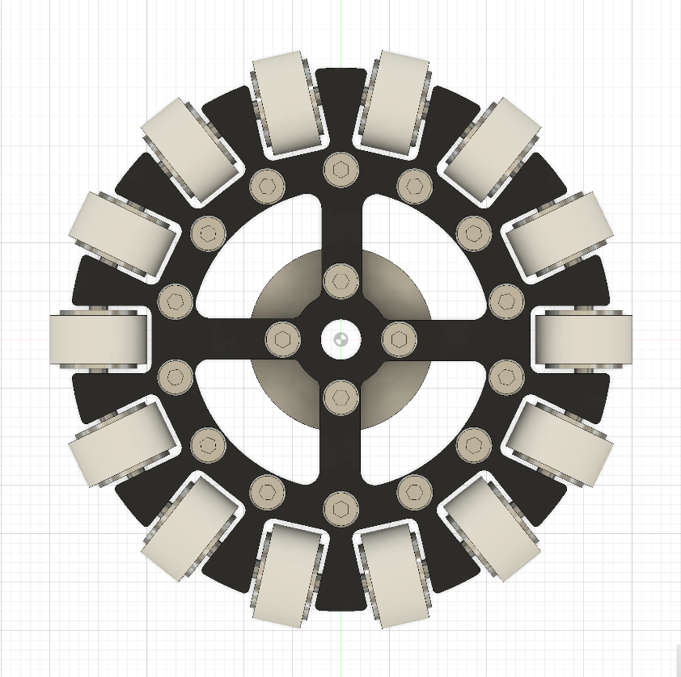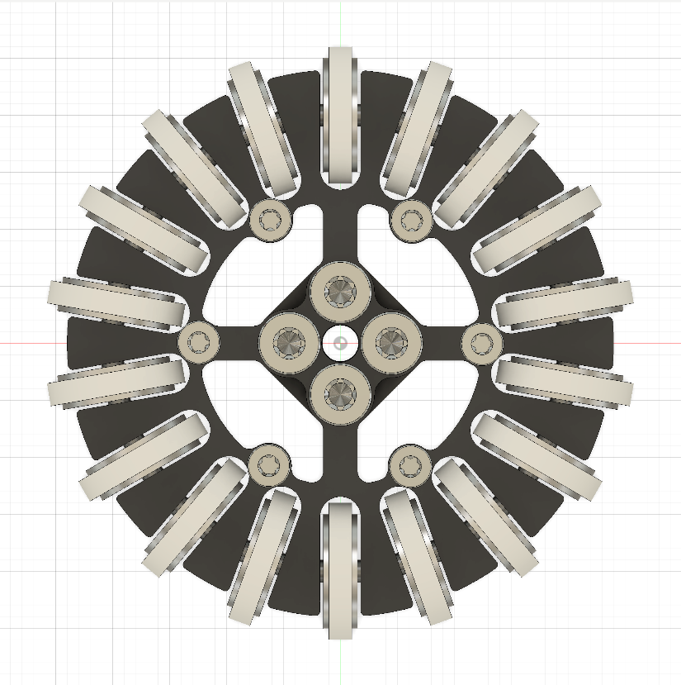

Fig.9 The old and new omni wheel

Previously, as shown in the left of Fig.9, we used omni-wheels with thick side wheels. However, starting from the 2023 Japan Open, we switched to a design with thin side wheels, as shown in the right of the Fig.9.

Fig.10

In the previous design, moving in direction →① was not a problem, but when moving in direction →②, the large contact area with the ground required more force due to increased friction. In the current design, the thin side wheels reduce the contact area with the ground, resulting in less friction and allowing for easier movement with less force. Additionally, the difference in the amount of force needed depending on the direction is minimized, leading to less speed variation and more stable robot movement.

**<Robot2 Mechanical>**

コンピューターの画面が表示されたゲーム画面

**・Designing**

Fig.11 Fig.12

We use Autodesk Fusion for the design of Robot 2 and KiCad 6.0 for the circuit design. By using these software tools, we have been able to develop a high-performance robot.

**・Expansion Of The Ball Capture Zone**

The robots we developed and produced up until the Japan Open 2023 had a narrow ball capture area, making it difficult to move the ball forward effectively and capture it smoothly during matches. (fig.13) For the robots developed for the world competition, we have expanded the ball capture area compared to the previous robots. (fig.14) This expansion has resolved the issues faced by the earlier robots, significantly improving the ball capture rate.

fig.13 fig.14

**・Improvement Of The Line Sensor**

Until the Japan Open 2024, our robots were equipped with only circular line sensors. However, with only the circular line sensors, it was challenging to fully detect the white lines, leading to frequent out-of-bounds occurrence.

This time, as shown in the figure, we added side line sensors in addition to the circular ones.

This addition has significantly reduced the out-of-bounds rate compared to before.

**・Motor Specifications**

We use the DIGILENT IG22 1/19 motor. This motor is lightweight and compact yet offers high responsiveness and speed, which is why we chose it. Previously, we used motors with high torque and high rotation speed but lacked responsiveness, making posture control and sudden direction changes difficult, and programming the robot was extremely challenging. From this iteration, we have started using motors that combine high responsiveness.

**・Solenoid Specifications**

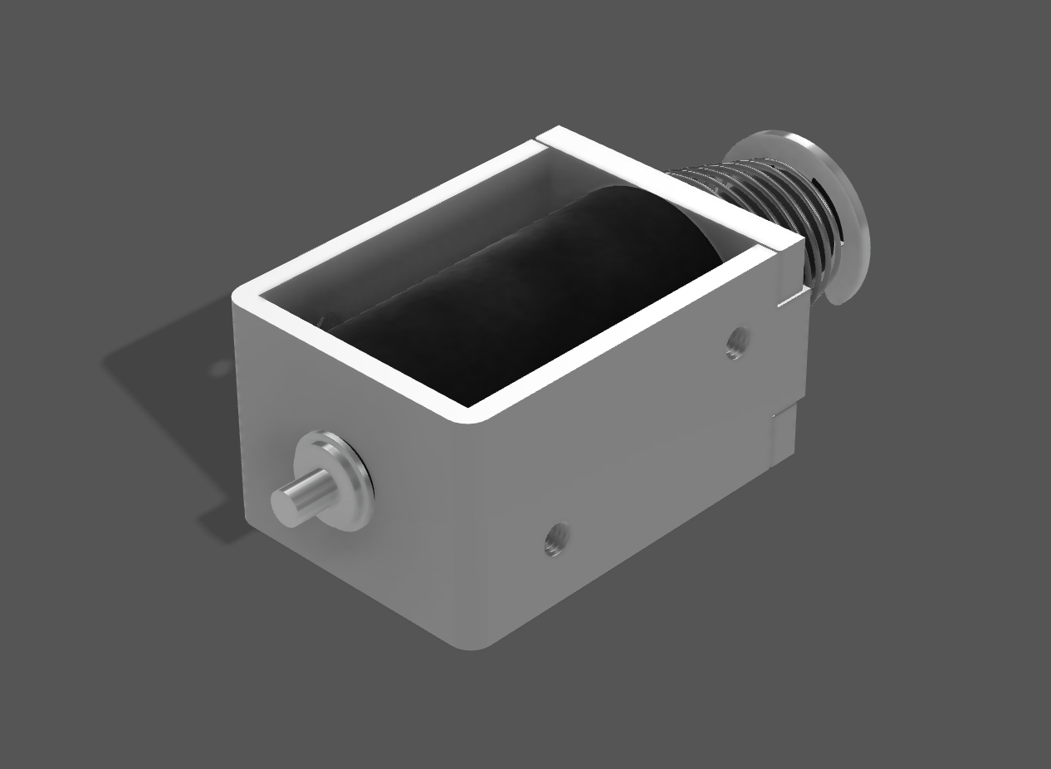We use the TAKAHA solenoid for the kicker.

Specifically, we have chosen the CB1037 push solenoid from TAKAHA, which has a long stroke and delivers high output despite its small size.

The kicker circuit is explained in detail on the next page under the section <Electric Circuits>.

**<Electric Circuits>**

Our robots consist of two types, but we try to use the same circuits as much as possible to quickly determine the cause in the event of a failure and to make parts redundant.

In this document, we wrote about our power supply circuit and kicker circuit.

**・Power Supply Circuit**

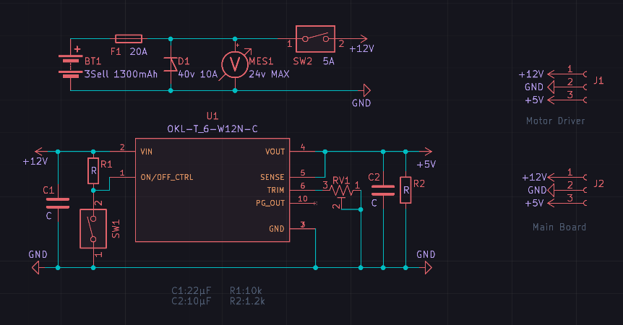 電子機器の部品

Fig.15 (circuit of the power supply) fig.16 (the circuit board)

The power circuit board includes a battery protection, and circuits for generating both the drive power supply and control power supply. The battery protection circuit is equipped with a reverse connection, overcurrent, and over-discharge prevention. To generate the control power supply, a DC-DC converter is used. By using a DCDC converter, electrical noise caused by motors and voltage drops due to the use of a kicker can be blocked, and a constant, stable power supply for control can always be provided. This ensures stable operation of the robot without resetting the microcontroller or sensors, even when equipped with high power motors or power-consuming dribbler mechanisms.

**・Kicker Circuit**

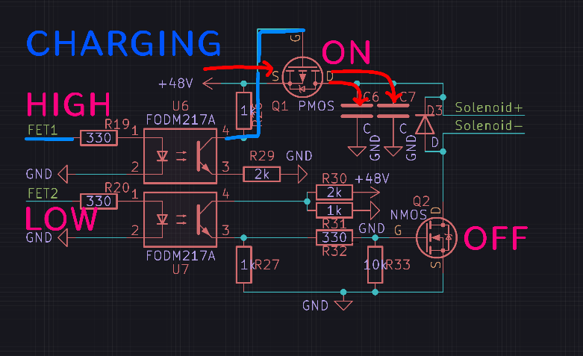 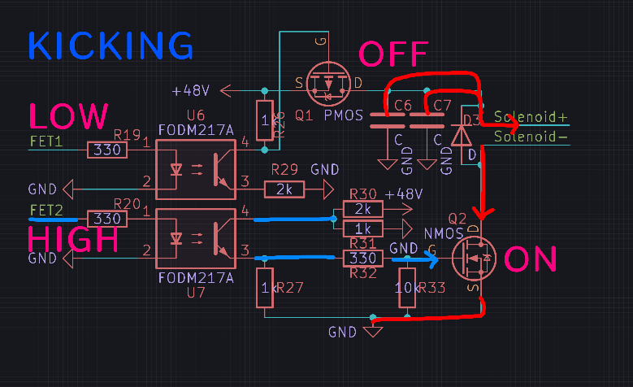

Fig.17 (circuit of the kicker circuit while charging) Fig.18 (circuit of the kicker circuit while kicking)

Previously, we did not implement noise countermeasures, resulting in voltage drops and unstable supply to the control power. This time, we have made numerous improvements to the kicker circuit to minimize noise as much as possible.

Firstly, to prevent noise from directly affecting the microcontroller, we have introduced a photocoupler into the signal lines. Secondly, we use separate FETs for solenoid control and isolate the kicker circuit from all other circuits only at the moment of the kick. This approach not only prevents noise from directly reaching the control circuits but also eliminates noise transmission through the power supply, leading to a much more reliable kicker circuit.

**<Robot1’s Software>**

**・Processing of the Defense Program**

Fig.19 Defender System

Robot.1 primarily serves as a defender. The defense system is implemented using two types of sensors: a circular line sensor and a ball sensor. The robot stays on the goal line and moves or stops based on the ball's angle of response.Fig.19 illustrates the defense system, where the large translucent circle represents the robot, and the smaller red and white circles within it represent the line sensors.

In Fig.19(①), when the ball is detected within ±15° of the perpendicular angle formed by the line connecting the active line sensors, the robot stops. In Fig.19(②), when the ball is detected beyond ±15° of the perpendicular angle, the robot moves in the direction indicated by the line sensor's angle towards the ball. Previously, the robot only moved in the direction of the ball while on the white line, which caused inefficiencies in returning to the goal line. By adjusting the movement direction based on the line sensor's response angle, the system now achieves two objectives simultaneously: staying on the goal line and moving towards the ball. This improvement allows for smoother movements and more effectively blocks the opponent's shots on goal.

**・Line Sensor Algorithm**

Fig.20 An algorithm of Circle Shape Line Sensor

Like Robot.2, Robot1 is equipped with a circular line sensor. By using a circular line sensor, the robot can accurately detect how it is crossing the white line, significantly improving the accuracy of out-of-bounds prevention.Fig.20 illustrates the algorithm of the sensor. In the figure, the right side of the white lines represents the inside of the court, while the left side represents the out-of-bounds zone.

In cases ① and ②, the robot moves in the direction opposite to the sensors that detect the white line.

In case ③, the detected direction would normally cause the robot to move towards the out-of-bounds zone. However, by comparing the current angle of detection with the previous one, if there is a significant change, the robot recognizes that it has crossed more than halfway over the line. It then moves in the opposite direction to avoid going out of bounds. This way, the circular line sensor ensures the robot calculates the correct direction to move, even if it has crossed the line by more than half.

ゲームの画面

**<Robot2’s Software>**

**・Color tracking using a camera**

Fig.21 360 view ＆ robot movement

Fig.21 shows an example of color tracking using OpenMV. By using an omni directional mirror, it is possible to see the entire court area at 360 degrees. In this example, thresholds for the colors of the goal and court are set as arc tangents, calculating angles and distances from the camera center simultaneously. The calculated angles and distances are transmitted via UART to the main microcontroller. Using the angles, the deviation between the goal's center direction and the robot is calculated, enabling PID control to orient towards the goal direction. This approach improves goal alignment rates compared to using only a gyro sensor. However, issues arose due to variations in lighting affecting how the goal appears. To address this, adjustments were made to the gamma value, contrast, and brightness of the images obtained from the camera, allowing the robot to adapt the visibility of the goal based on the current environment.

Regarding the Attacker mechanism, previously, the robot would orient towards the goal direction when the goal was visible and towards the front direction using the gyro sensor when the goal was not visible. However, a problem was identified at the national tournament where the visibility of the goal frequently alternated at the boundary of visibility, disrupting smooth movement as the direction control switched between gyro direction and goal direction. Therefore, a new approach was implemented where the robot faces the goal direction when holding the ball or when near the goal (as shown in Fig21). This change prevents frequent switching between goal and gyro directions, leading to an improved goal alignment rate.

**<Review ＆ Future Goals>**

Our final goal is to achieve victory in both the Lightweight League and the Open League.

Reflecting on this season, we aim to develop an even better robot for the upcoming season based on the following lessons learned:

**Improvements in Design:** We aim to enhance performance by continuing to lighten the robot and strengthen its structure. Optimizing component placement and design shapes will further improve maintenance and durability.

**Sensor and Control Systems:** We plan to refine the accuracy and reliability of color tracking using cameras.

**Enhancing Stability and Accuracy of Operations:** Prioritizing responsiveness in gyro sensors and motors will enhance operational stability. Optimizing software algorithms will ensure flexibility in handling unforeseen situations.

**Refinement of Competitive Strategies:** Further refining the roles of attackers and defenders will allow for more strategic gameplay. We will consider additional features to support strategic play.

**Team Coordination and Communication:** Enhancing the use of project management tools will streamline team progress tracking and issue resolution. Improving communication among team members will foster better collaboration.

We are committed to developing a robot that is more advanced and competitive, building on the challenges and successes of this season.

**<URL>**

・Our team HP: <https://munako-artemis.github.io/>

・GitHub: [https://github.com/MUNAKATA-EPC/](https://github.com/MUNAKATA-EPC/Artemis_2023)

・Contact us: [kyle.matsuda.0518@gmail.com](mailto:kyle.matsuda.0518@gmail.com)

This document only covers a part of our robot.

If you have any other questions or concerns, please contact us.